Easter in Germany

Easter in German is called Ostern and to wish someone a Happy Easter you say Frohe Ostern. Good Friday is called Karfreitag.

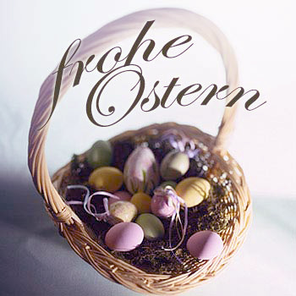

Gründonnerstag is the name given to the day before Good Friday – Maundy Thursday. On that day it's traditional to eat green dishes such as "seven herb soup" containing spinach, parsley, leeks, chives, dandelion and sorrel. Green Easter eggs are also eaten.
Oberammergau Passion Play

A passion play is one which tells the story of the life and death of Jesus Christ and the one which is performed in Oberammergau in the South of Germany is very famous. The play lasts for up to 6 hours and about 1200 villagers participate in it, but it only happens every 10 years. The next one will be in 2010. It takes place because of a promise that the villagers made to God in 1632, when a disease called the Black Death was killing many people in Europe. They said they would re-enact the play every 10 years if they were saved.

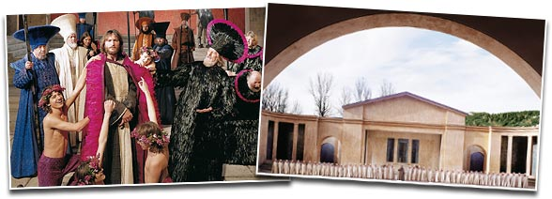
Easter Bonfire
Another typical German tradition is the Easter bonfire. On the eve of Easter Sunday, the Germans light big bonfires across the country to end the last signs of the cold winter season and to welcome the spring and the sun. Much of the wood used for the bonfire is old Christmas trees which have been collected and saved for the occasion. Beer, hot punch and grilled sausages are offered to make it more of a celebration.
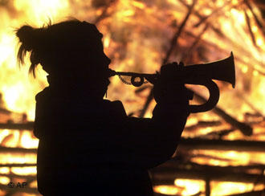
Easter Tree

In German households there is often much Spring cleaning in preparation for Easter and then decorations are brought into the home, twigs with buds, crocuses and daffodils, willow and birch.
Easter trees (Osterstrauch) have long been part of German Easter celebrations. These trees are decorated with blown-out eggs, which are dyed or painted and hung with ribbon on special branches throughout the week of Easter.

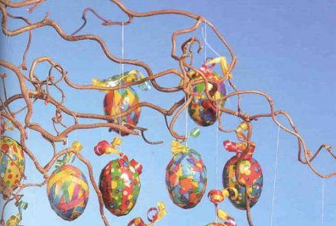
The Easter Hare (Die Osterhase)

The tradition of the Easter Bunny started in Germany and still plays a very important part in the celebrations. It is the Osterhase who brings Easter eggs for the children and he usually hids them in the garden, sometimes in little nests. On Easter Sunday (Ostersonntag) the children go on treasure hunts to find them.

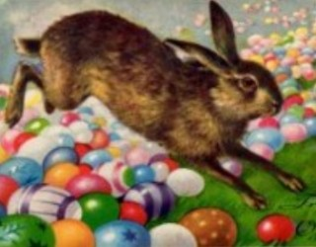
Easter Food in Germany

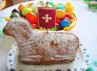

- On Good Friday people traditionally eat fish.
- The high point of German Easter celebrations is, of course, Easter Sunday, when a festive meal is eaten. This is often roast lamb.
- Sometimes a special cake/sweet bread in the shape of a lamb is also eaten. This is called Lämmle.
- Kruller, which are like doughnuts are also traditional.
German Easter Games

- Ostereiermalen – painting eggs
- Chocolate kiss
- Osterei im Berg – egg hidden in a pile of sand or salt
- Easter egg treasure hunt in the garden

